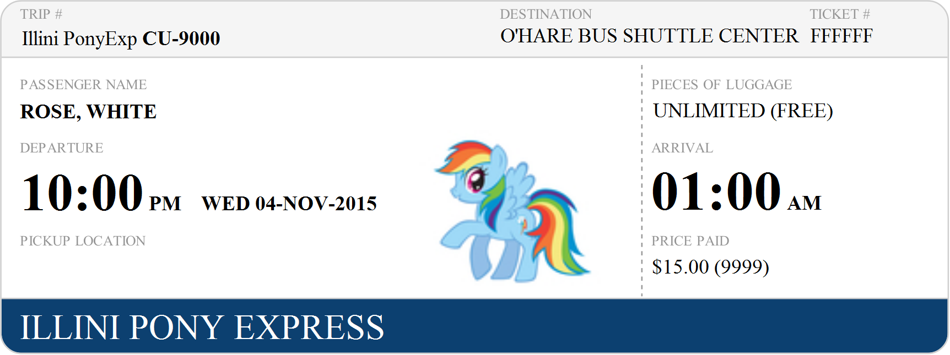
Illini Union Bookstore
40° 06’ 29” N
88° 13’ 44” W

